**Technical Report**

***Raghav -20BCE7383***

**Table of Contents:**

| S. No | Topic | Page Number |
| --- | --- | --- |
| 1 | Summary | 3 |
| 2 | Abstract | 4 |
| 3 | Objective | 5 |
| 4 | Dataset | 5 |
| 5 | Source Code | 6 |
| 6 | Conclusion | 15 |
| 7 | References | 15 |
| 8 | Acknowledgement | 16 |

**Summary:**

At the end of the Home Loan project. We will observe how to conduct data visualization. We get hands-on experience of various packages in Python language. Hands on with different algorithms to understand the data and work on real world projects.

**Abstract:**

We are creating a Data Analysis Project on Home Loan. Customer first apply for home loan after that company validates the customer eligibility for loan.

The Company wants to automate the loan eligibility process (real time) based on customer detail provided while filling online application form. These details are Gender, Marital Status, Education, Number of Dependents, Income, Loan Amount, Credit History and others. To automate this process, they have given a problem to identify the customers segments, those are eligible for loan amount so that they can specifically target these customers.

It’s a classification problem , given information about the application we have to predict whether the they’ll be to pay the loan or not.

We’ll start by exploratory data analysis , then preprocessing , and finally we’ll be testing different models such as Logistic regression, SVM, Random forest and Neural Network.

**Objective**:

The goal of our Home Loan analysis project is to determine if a customer should get loan approval or not. Our analysis can answer the complex queries for approving home loan. Therefore, it can be helpful banking sector to make intelligent financial decisions.

**Dataset:**

The dataset has been taken from Github(https://github.com/Gianatmaja/Customer-Segmentation-on-Home-Loans/blob/main/Train_Loan_Home.csv).

**Imported libraries:**

We imported several libraries for the project:

pandas

numpy

matplotlib.pyplot

seaborn

**Import dataset**

After downloading the dataset from Github, I saved it to my working directory with the name Train_Loan_Home.csv. Next, I used read_csv() to read the dataset and save it to the df variable.

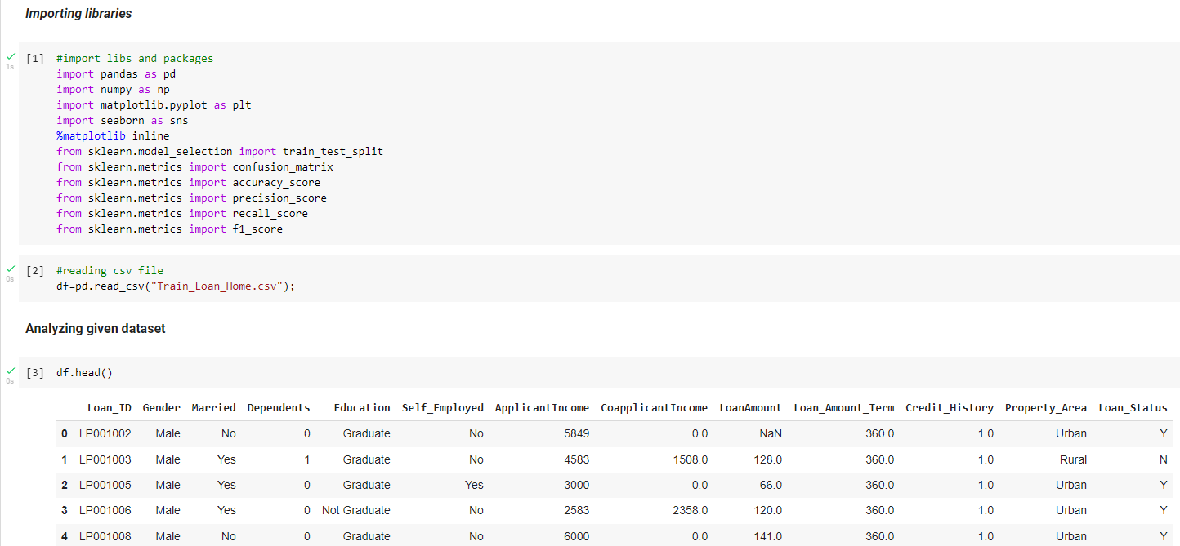

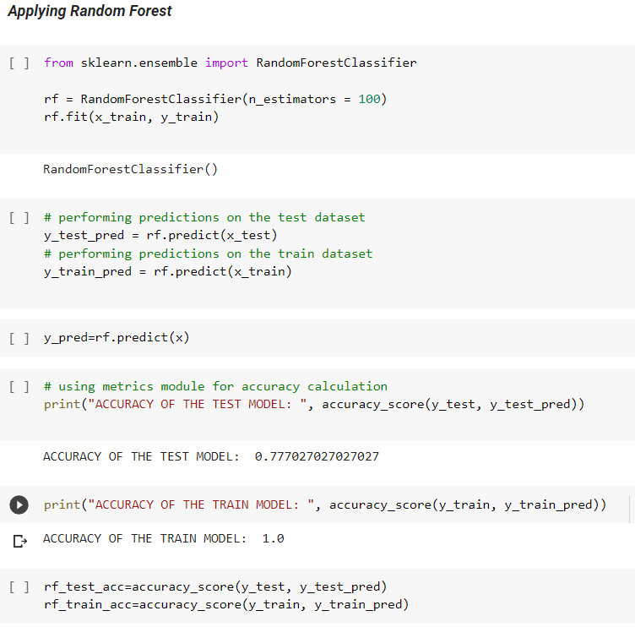

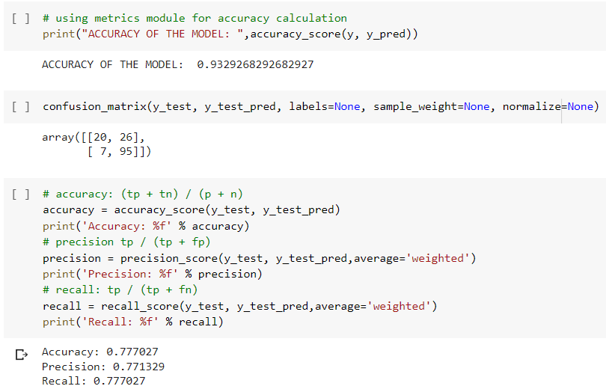

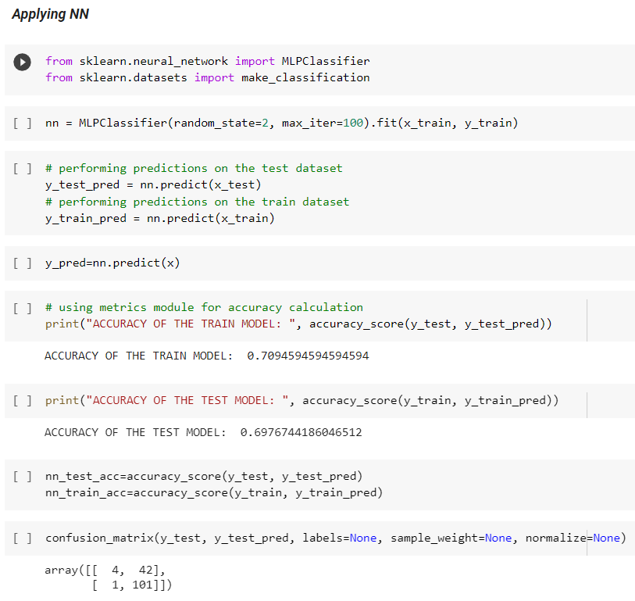

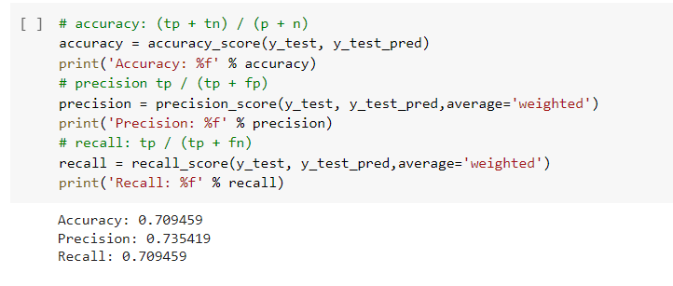

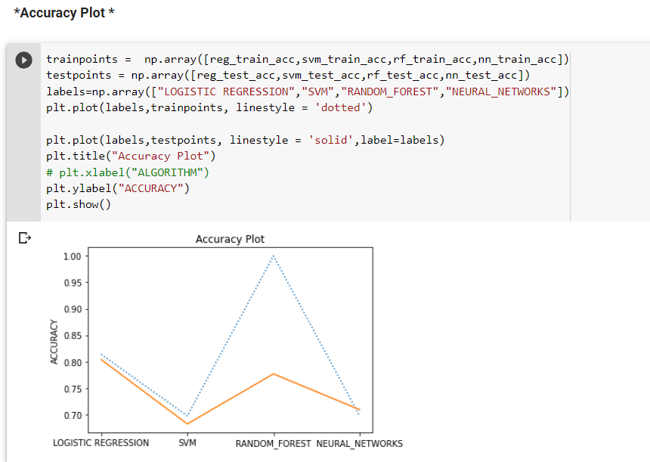

**Conclusion:**

So, we conclude by saying that this project Home Loan analysis is extremely much useful in everyone’s day to day life and it's mainly more important for the Banking sector, because they're the one that daily uses these systems to predict the loan approval of the Customer. The distributions of the Gender, Marital Status, Education, Number of Dependents, Income, Loan Amount, Credit History and others, target is analysed, and the conclusion is drawn. The conclusion which we found is that this project performed better in this analysis.

**References:**

* **🡪https://github.com/Gianatmaja/Customer-Segmentation-on-Home-Loans/blob/main/Train_Loan_Home.csv**

**Acknowledgement:**

The satisfaction that accompanies that the successful completion of any task would be incomplete without the mention of people whose ceaseless cooperation made it possible, whose constant guidance and encouragement crown all efforts with success. We are very grateful to our project guide, for the help and support for our project work.